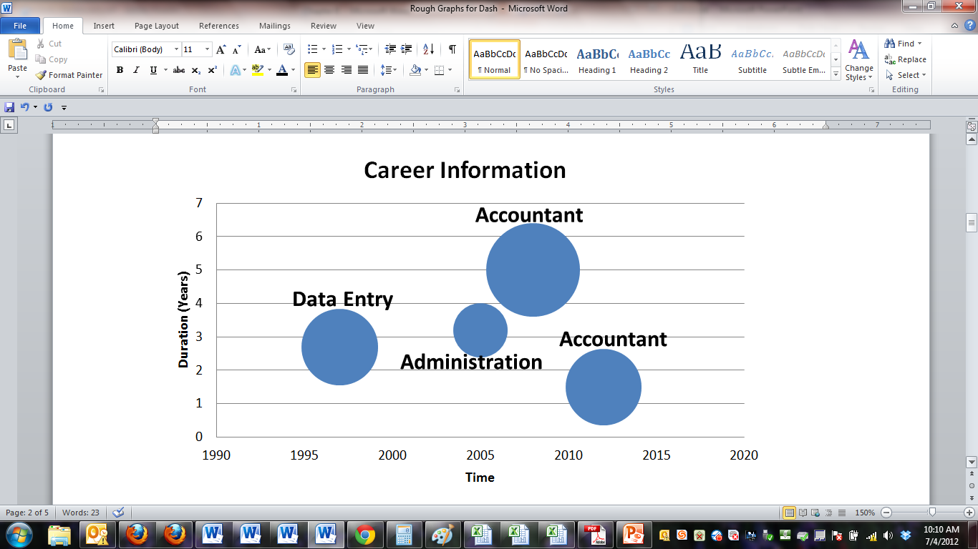

**Accountant**

**Data Entry**

**Administration**

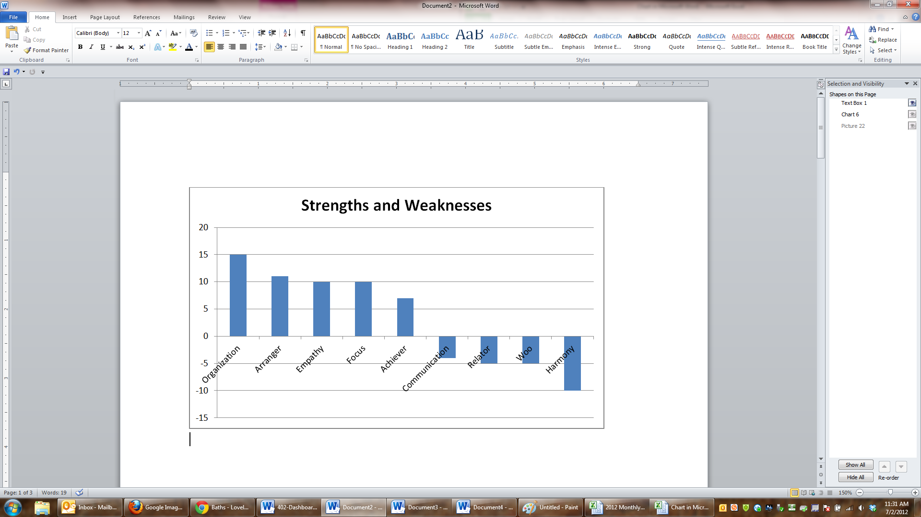

**Monthly Church Involovement**

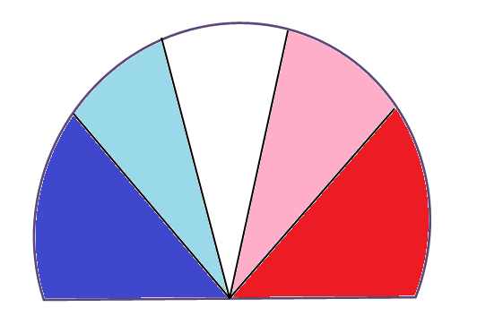

**20**

**18**

**16**

**14**

**12**

**10**

**8**

**6**

**4**

**2**

**Days**

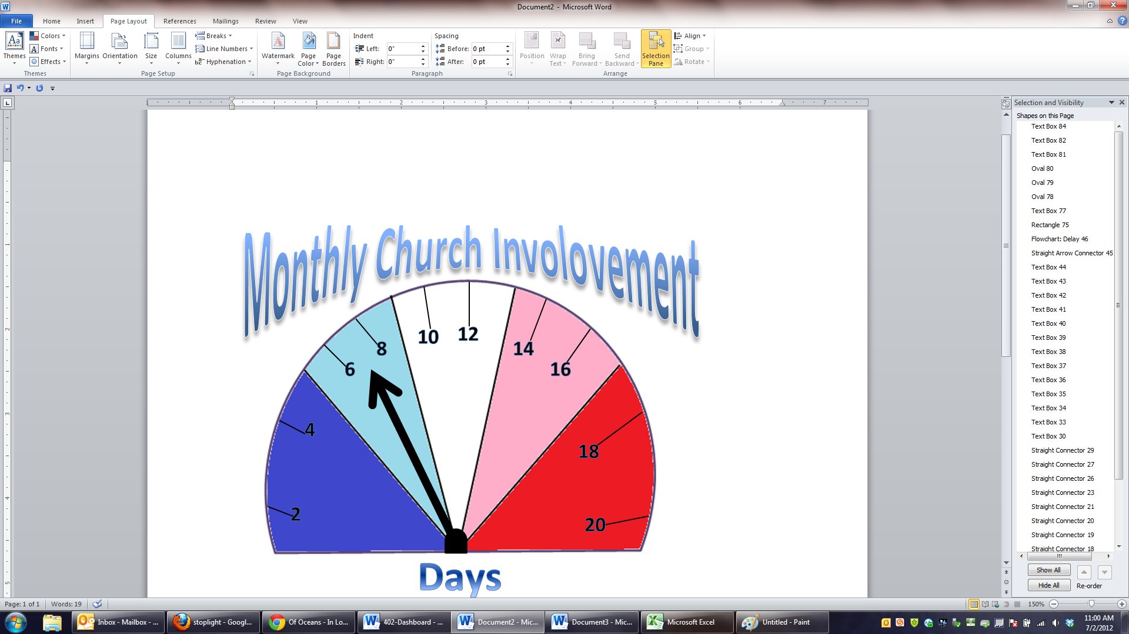

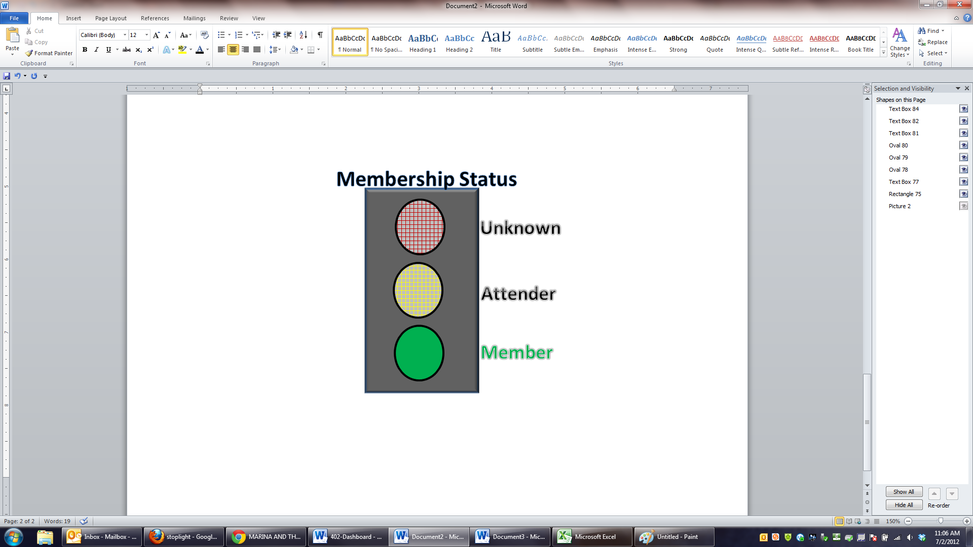

**Unknown**

**Attender**

**Member**

**Membership Status**